

Bachelor of Game Development (Hons)

**XBGT**2094**N**

ASSIGNMENT

**DOCUMENTATION**

Semester May **2024**

**Joshua Yeoh**

**0135760**



# Themed Post-Processing

The effects used are Spherize, Zoom, Vignette, Tiling Scanlines, and Greyscale

First, I try to spherize the UV, then grayscale, then add scanlines, then finally add vignette

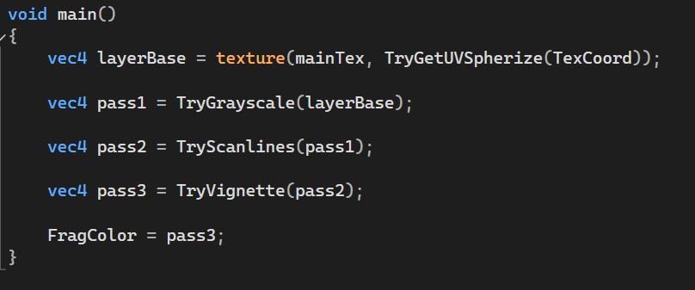

With no post-processing:

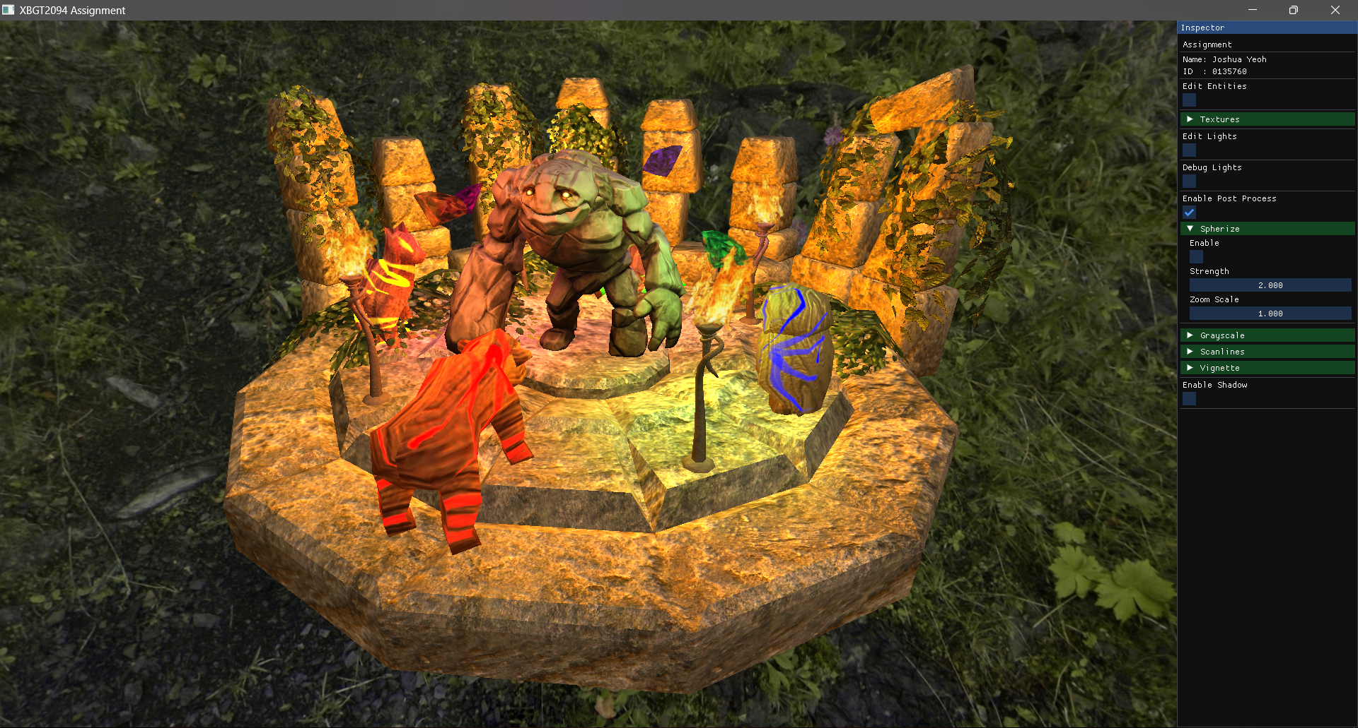

First is Spherize. I take the texture coordinates and distort them into a spherical shape to get that fisheye effect  
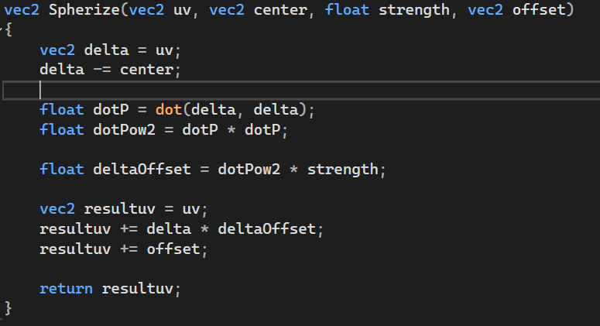

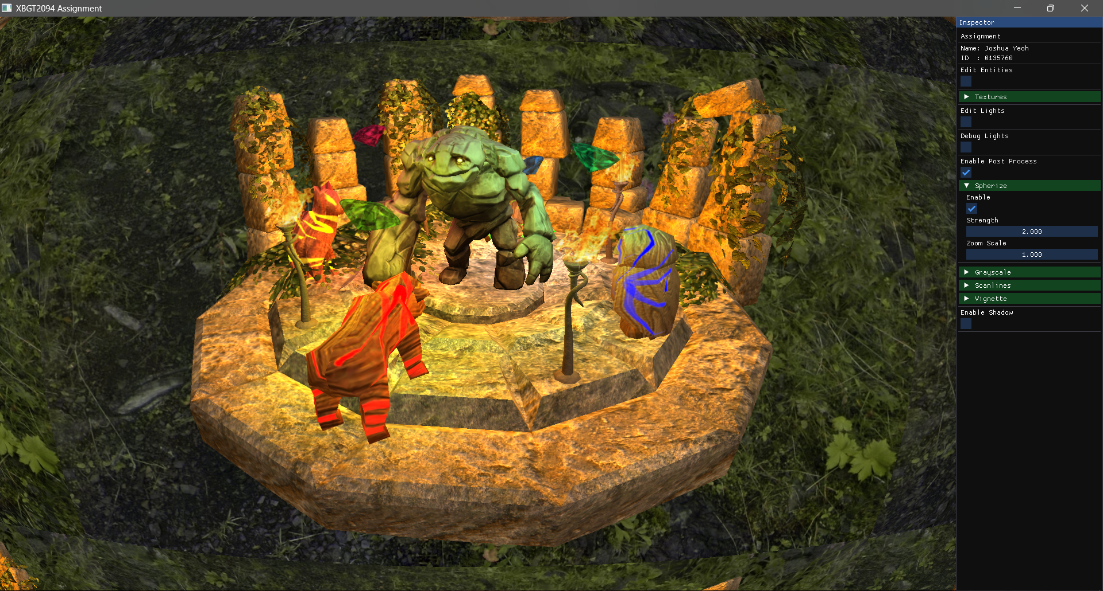

After I spherize the UV, I zoom in to try and move the weird borders out of the frame a bit  
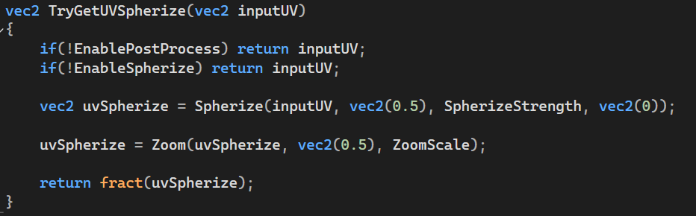

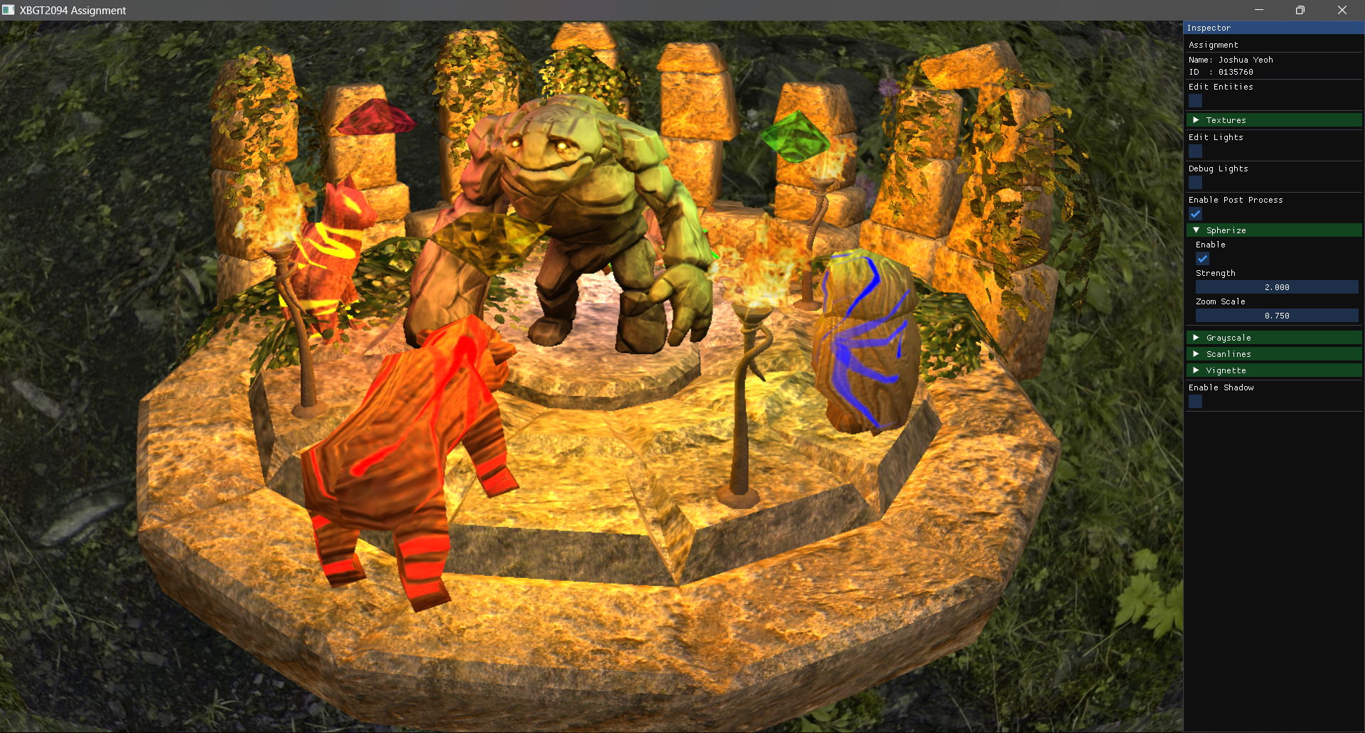

And then I add grayscale effect

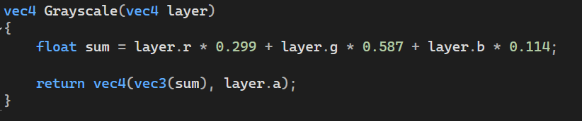

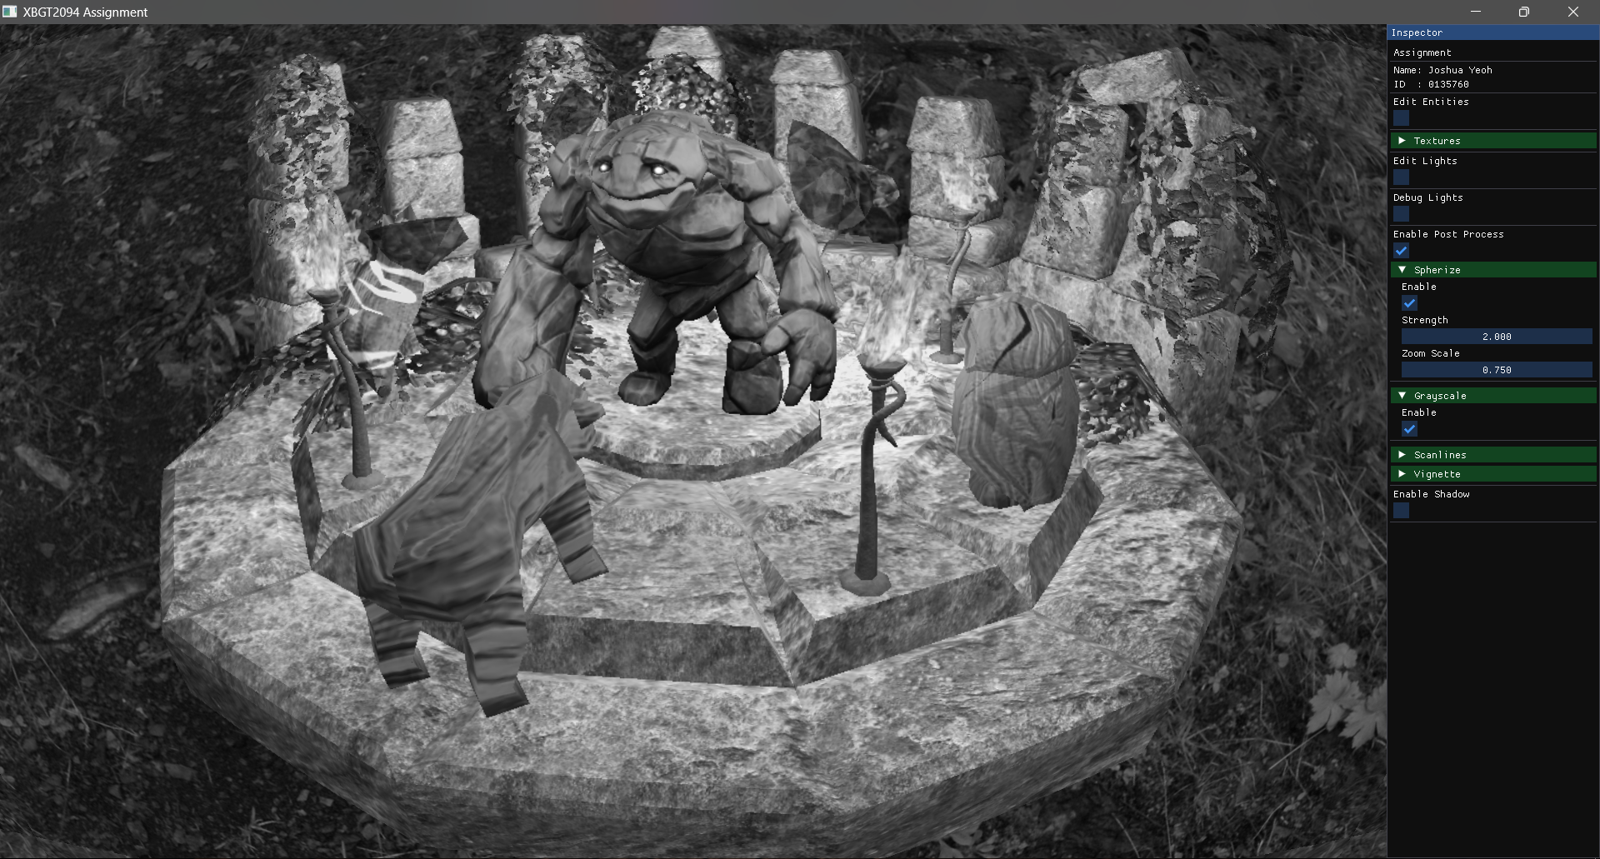

Then I add a scanline texture overlay. If Spherize effect is also on, then the scanline uv will also distort. To make the scanlines scroll up or down, I used the Tile effect and used the time value to move the y axis.

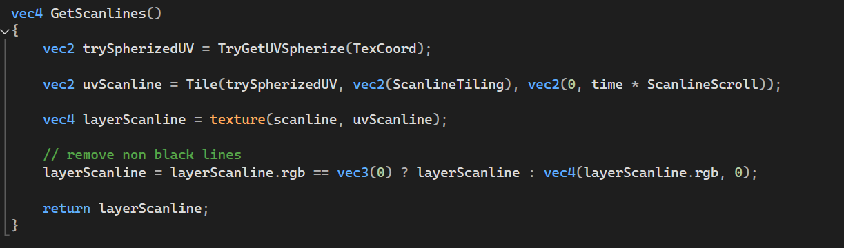

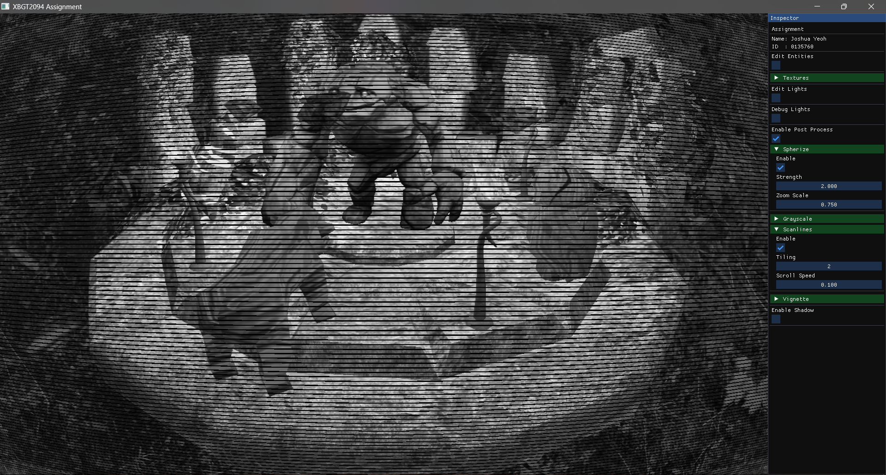

Lastly, I add the vignette effect for darker edges.

The main vignette code was created by Ippokratis in 2016-05-21 from shadertoy.com.

I just added the ability to change the vignette colour.  
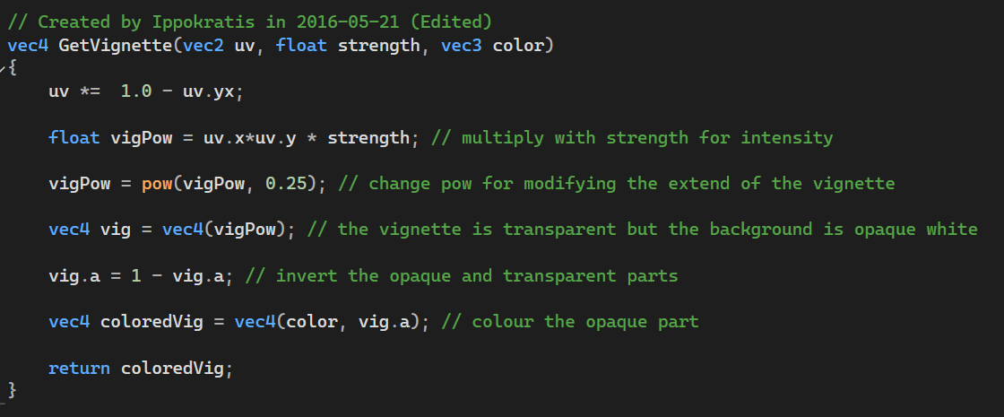  
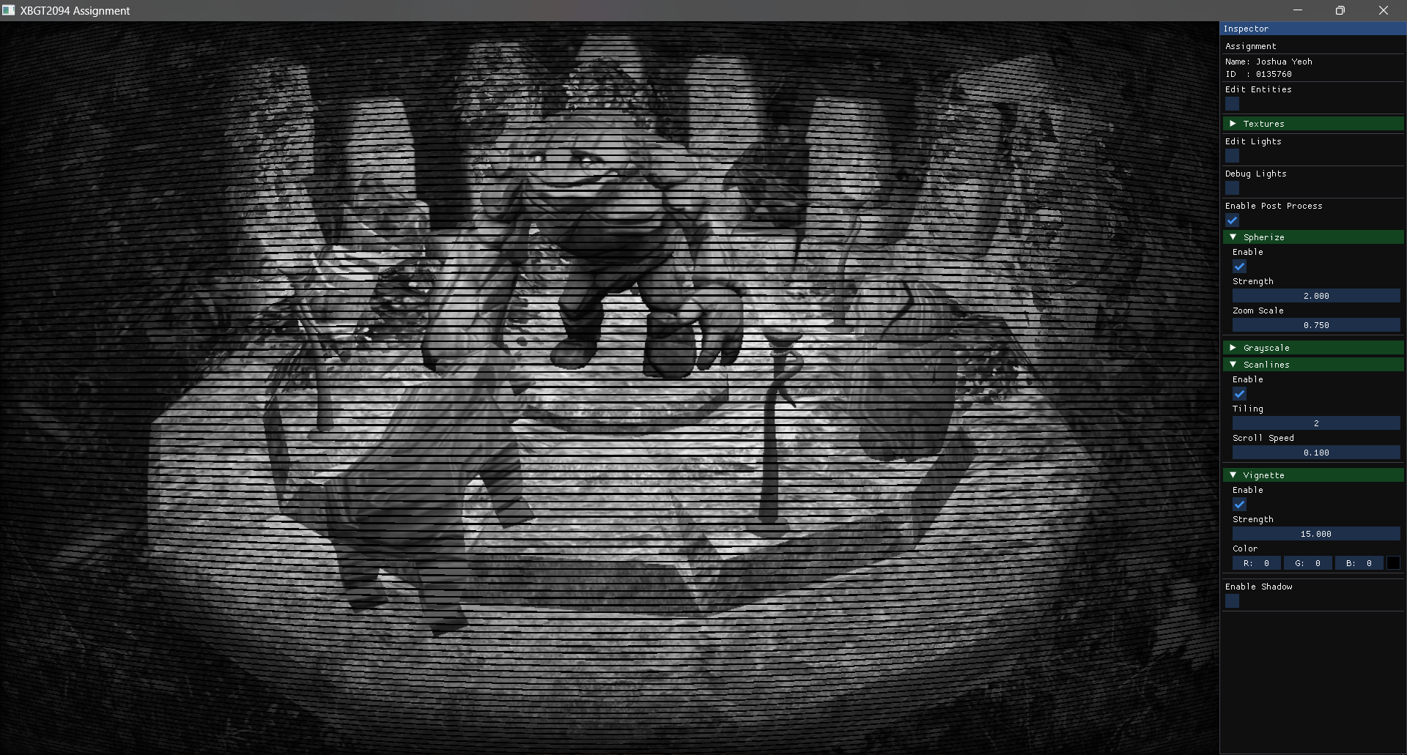

The effects can be individually toggled and tweaked in the inspector.

# Credits

Simple vignette effect by Ippokratis

<https://www.shadertoy.com/view/lsKSWR>

Forest skyboxes by Emil Persson

<https://opengameart.org/content/forest-skyboxes>

3TD Fantasy Ruins Pack by Ron Kapaun

<https://opengameart.org/content/3td-fantasy-ruins-pack>

Animal Figurines by Clint Bellanger

<https://opengameart.org/content/animal-figurines>

Gems by Clint Bellanger

<https://opengameart.org/content/gems>

fantasy torch by rubberduck

<https://opengameart.org/content/fantasy-torch-pack-1>

Flame Particle by Keith333

<https://opengameart.org/content/flame-particle-set-4-in-total>

Normal Map Online by Christian Petry and Am Gänsweiher

<https://cpetry.github.io/NormalMap-Online/>

Learn OpenGL and Shadow Maps (Directional Lights) Tutorial by Victor Gordan

<https://learnopengl.com/Advanced-Lighting/Shadows/Shadow-Mapping>

<https://youtu.be/9g-4aJhCnyY?si=dAAKu7lS9MZcFn7L>

(When I was attempting renderer feature)